**EUROPOL AND PALO ALTO NETWORKS EXPAND THEIR COOPERATION IN TACKLING CYBERCRIME**

*23 October 2019*

*Press Release*

[Print](https://www.europol.europa.eu/print/newsroom/news/europol-and-palo-alto-networks-expand-their-cooperation-in-tackling-cybercrime)[PDF](https://www.europol.europa.eu/printpdf/newsroom/news/europol-and-palo-alto-networks-expand-their-cooperation-in-tackling-cybercrime)

* [E-mail](mailto:?subject=Europol%20and%20Palo%20Alto%20Networks%20expand%20their%20cooperation%20in%20tackling%20cybercrime%20%7C%20Europol&body=https%3A%2F%2Fwww.europol.europa.eu%2Fnewsroom%2Fnews%2Feuropol-and-palo-alto-networks-expand-their-cooperation-in-tackling-cybercrime)
* [Facebook](http://www.facebook.com/share.php?u=https%3A%2F%2Fwww.europol.europa.eu%2Fnewsroom%2Fnews%2Feuropol-and-palo-alto-networks-expand-their-cooperation-in-tackling-cybercrime&t=Europol%20and%20Palo%20Alto%20Networks%20expand%20their%20cooperation%20in%20tackling%20cybercrime%20%7C%20Europol)
* [Twitter](https://twitter.com/intent/tweet?url=https%3A%2F%2Fwww.europol.europa.eu%2Fnewsroom%2Fnews%2Feuropol-and-palo-alto-networks-expand-their-cooperation-in-tackling-cybercrime&text=Europol%20and%20Palo%20Alto%20Networks%20expand%20their%20cooperation%20in%20tackling%20cybercrime%20%7C%20Europol)
* [LinkedIn](http://www.linkedin.com/shareArticle?mini=true&url=https%3A%2F%2Fwww.europol.europa.eu%2Fnewsroom%2Fnews%2Feuropol-and-palo-alto-networks-expand-their-cooperation-in-tackling-cybercrime&title=Europol%20and%20Palo%20Alto%20Networks%20expand%20their%20cooperation%20in%20tackling%20cybercrime%20%7C%20Europol&ro=false&summary=&source=)

THIS NEWS/PRESS RELEASE IS ABOUT [CYBERCRIME](https://www.europol.europa.eu/crime-areas-and-trends/crime-areas/cybercrime)

[*View all crime areas*](https://www.europol.europa.eu/crime-areas-and-trends/crime-areas)

[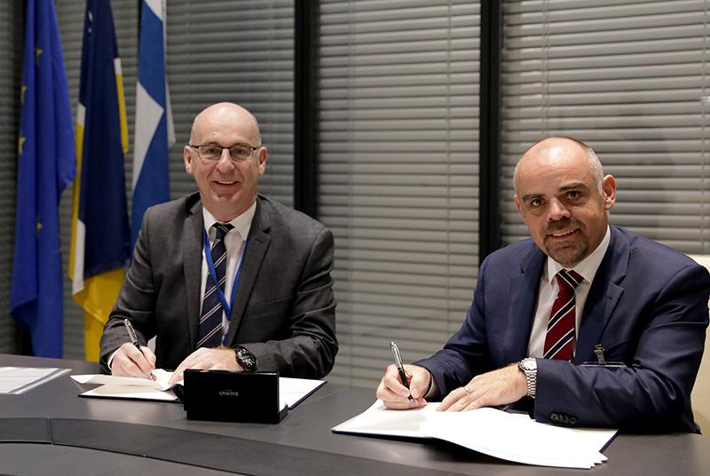](https://www.europol.europa.eu/sites/default/files/styles/europol_extra_large/public/images/fd9a0184.jpg?itok=5HsbIkpA)

[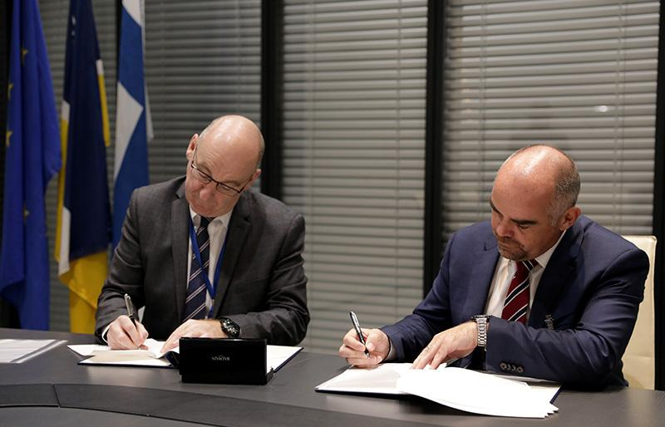](https://www.europol.europa.eu/sites/default/files/styles/europol_extra_large/public/images/fd9a0185.jpg?itok=wKYPzt3N)

[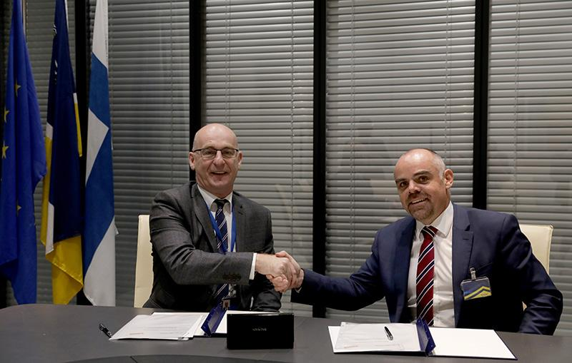](https://www.europol.europa.eu/sites/default/files/styles/europol_extra_large/public/images/fd9a0192.jpg?itok=oBPyrE-3)

Today, Europol and Palo Alto Networks have signed a Memorandum of Understanding (MoU) to expand their collaborative efforts in combating cybercrime and working together to make cyberspace safer for citizens, businesses and governments.

Enhancing cyber intelligence

The agreement builds on the already established cooperation between Europol’s [European Cybercrime Centre (EC3)](https://www.europol.europa.eu/about-europol/european-cybercrime-centre-ec3) and Palo Alto Networks, a member of EC3's Internet Security Industry Advisory Group since early 2017. It will include the exchange of threat intelligence data and details of cybercrime trends, as well as technical expertise and best practices. The already on-going cooperation will be reinforced with the dynamic exchange of cyber threat intelligence. An important focus of this intelligence exchange is extending the knowledge on new adversary behaviours, malware families and attack campaigns around the world. Building up expertise on these cyber threats is crucial to combatting them in the most effective way.

On the signing of the Memorandum of Understanding, the Head of Europol's European Cybercrime Centre, Steven Wilson, said: “The close collaboration between law enforcement and the global industry is crucial for countering effectively the increasing threat that criminals pose to the safety of the cyberspace. We are confident that working together with the leading companies in the cyber world will significantly enrich the toolbox of the global coalition against cybercrime. This kind of cooperation is the most effective way to protect citizens’ and businesses’ digital lives.”

Greg Day, vice president and chief security officer, EMEA, Palo Alto Networks, commented: “Cyber threats aren’t bound by borders, so we can’t afford to be siloed when it comes to tackling them either. International cooperation like this is important because we can have far more impact by working together. We are striving to build a world where each day is safer and more secure than the one before, so we look forward to working even more closely with Europol over the coming years to aid investigations and enforcement efforts to achieve this goal.” 

About Palo Alto Networks:

Palo Alto Networks, the global cybersecurity leader, is shaping the cloud-centric future with technology that is transforming the way people and organizations operate. Our mission is to be the cybersecurity partner of choice, protecting our digital way of life. For more information, visit [Palo Alto Networks website](http://www.paloaltonetworks.com).